**COA MINI PROJECT**

**RFID DOOR LOCK SYSTEM USING ARDUINO**

**ABSTRACT:**

The main objective of this project is to design a RFID door lock system that can give contactless experience, which can be easy to configure, is more secure, can create more awareness and have a low maintenance cost. RFID technology uses radio frequency to send and receive data, so there is no need to swipe a card or enter a key for it to work.

 Rather than cutting new keys and retooling locks, configuring an RFID entry system is primarily digital. This makes adjusting settings and making changes much easier. Also, the RFID tags are highly encrypted which provides added security to your system.

The technology is important when it comes to logging activity, as the system can record every time the RFID reader communicates with a tag. Thus, this system can become an important asset to prevent theft.

**INTRODUCTION**

Radio frequency identification (RFID) is a prominent technology for a wide array of applications, from inventory tracking to payment processing. When it comes to security, RFID door lock systems are very common for access control, as they provide a reliable, consistent experience with trackable data. Unlike other forms of traditional access control such as swipe cards, RFID locking systems are contactless, meaning that the credential doesn’t have to touch the reader for it to work.

Like a barcode reader, RFID readers work by sending and receiving data, but instead of having to scan a code, the data is transmitted over radio frequencies. An RFID door locking system requires RFID tags, antennas, an RFID reader, and a transceiver in order to function as a complete system.

In an RFID door lock access control system, the user’s credential (usually a key card or fob with an RFID chip) contains unique identifying information called a tag. When the user comes within proximity of a reader, the reader’s signal locates the information stored on the user’s RFID tag, and sends it through antennas and transceivers to authorize the tag in the access control system.

**REQUIRED SOFTWARE:**

ARDUINO IDE

**REQUIRED HARDWARE**:

**1.Arduino UNO**

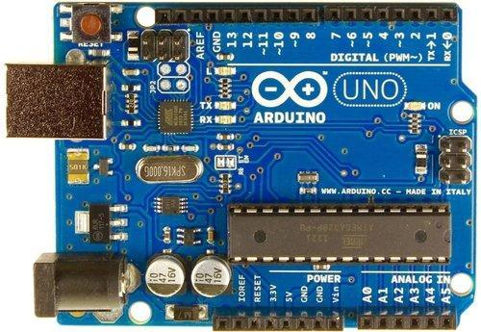

**2.RFID module x 1**

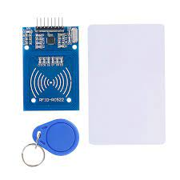

**3.Jumper Wires**

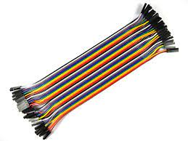

**4.Foam board**



**5.LCD display x 1**

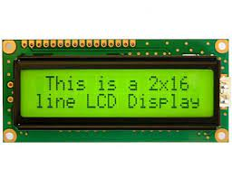

**6.I2C module x 1**

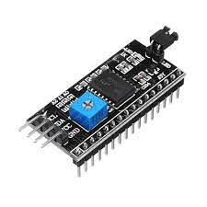

**7.Servo motor x 1**

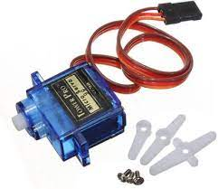

**8.Iron stick**

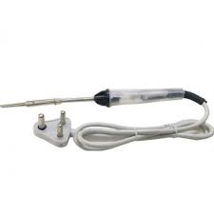

**WORKING:**

When Power ON this door lock, the servo motor activates and pushes the door lock forward. Also displayed as “Welcome put your card” on the LCD. Then when the RFID tag is moved closer to the RFID reader, it is scanned. In that case it is displayed as “scanning” on the LCD. Then if RFID tag is correct, the servo motor is activated and the door lock is pulled back. The LCD shows “Door is Open”. When the RFID tag is moved closer to the RFID reader again, if it gets the correct tag, the servo motor will push the lock forward. Displays “Door is locked” on LCD. If a wrong RFID tag is used according to the program, it will be displayed as “Wrong Card on the LCD.”

**PROCEDURE:**

**Step 1:**

Firstly, identify these components and solder the RFID module

**Step 2:**

Secondly, connect the servo motor and lock using iron stick.

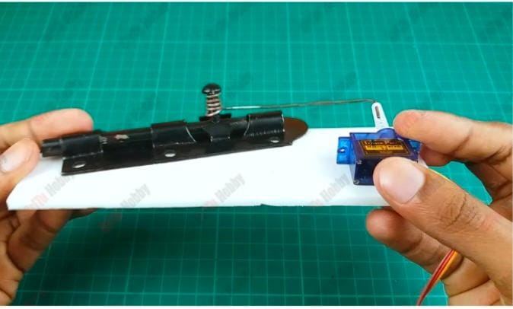

**Step 3:**

Thirdly glue this lock and servo motor to the foam board.

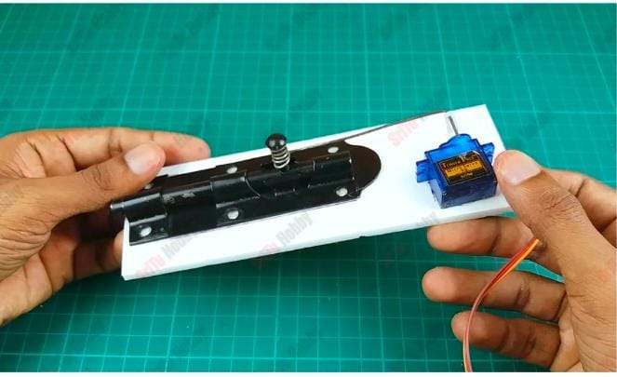

**Step 4:**

Connect all the components to the Arduino Board.

**Step 5:**

Create program for scan RFID Tags.

**Step 6:**

Select Arduino board and port.

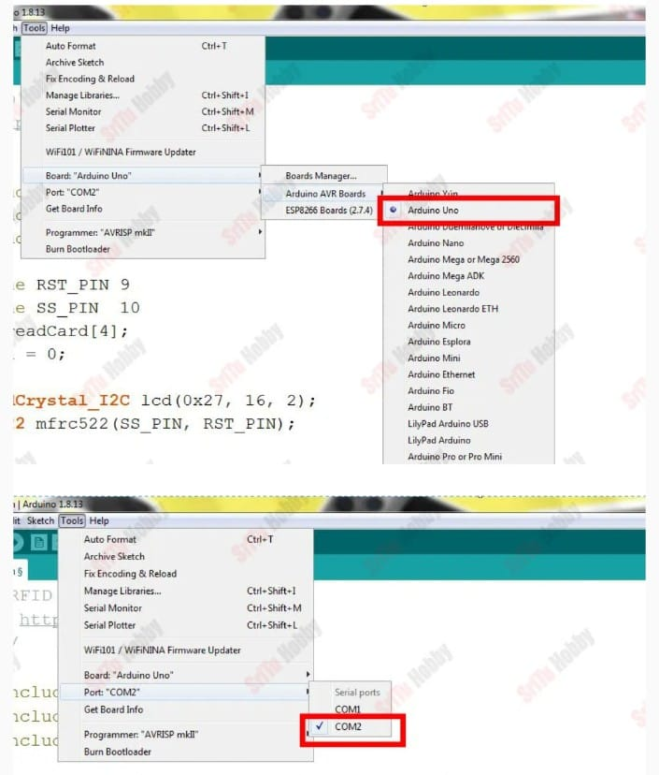

**Step 7:**

Upload code to Arduino board.

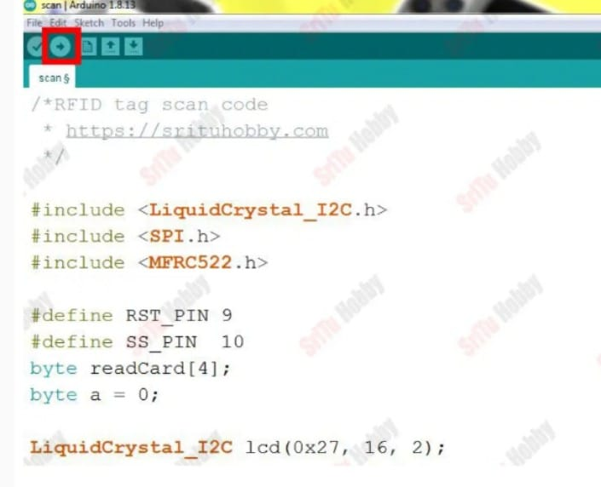

**CIRCUIT DIAGRAM:**

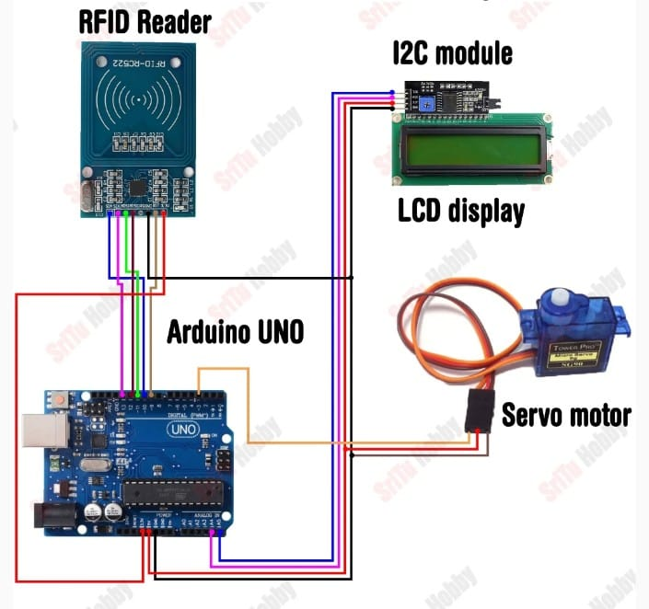

**CODE:**

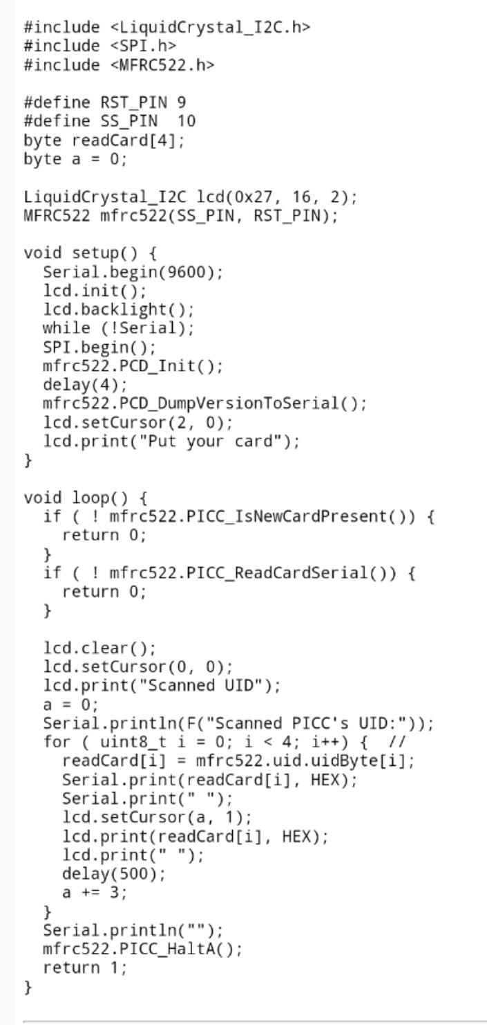

**FLOWCHART:**

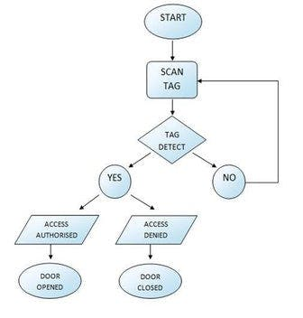

**Types of RFID door lock systems:**

* Low Frequency (LF)
* High Frequency (HF)
* Ultra-High Frequency (UHF)

**BENEFITS:**

* Cost-effective access control solution for internal doors
* One credential for every door in the building
* Combined dashboard for improved security monitoring
* Easy-to-deploy cloud integration with no additional wiring
* Complete access control for every door, across any size organization

**REAL LIFE EXAMPLE:**

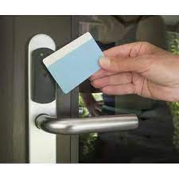

**CONCLUSION:**

Here we are going to make an evolution change towards safety. With the combination of intelligent door lock systems and safety technologies, these door locks are better and shoulders above traditional ones. It is equipped with smart devices like RFID, Arduino etc. Based on tag detection, if access is authorised then door will open otherwise the door will remain locked.

For social it will help towards theft, for business we try to make it affordable to many as many possible. So that Normal people to rich people can benefit from it. RFID door lock systems are very common for access control, as they provide a reliable, consistent experience with trackable data.

**TEAM MEMBERS:**

* RAKESH KUMAR PRUSTY RA2011043010044
* HELI ASHAR RA2011043010050
* VENKATESH IYER RA2011043010001